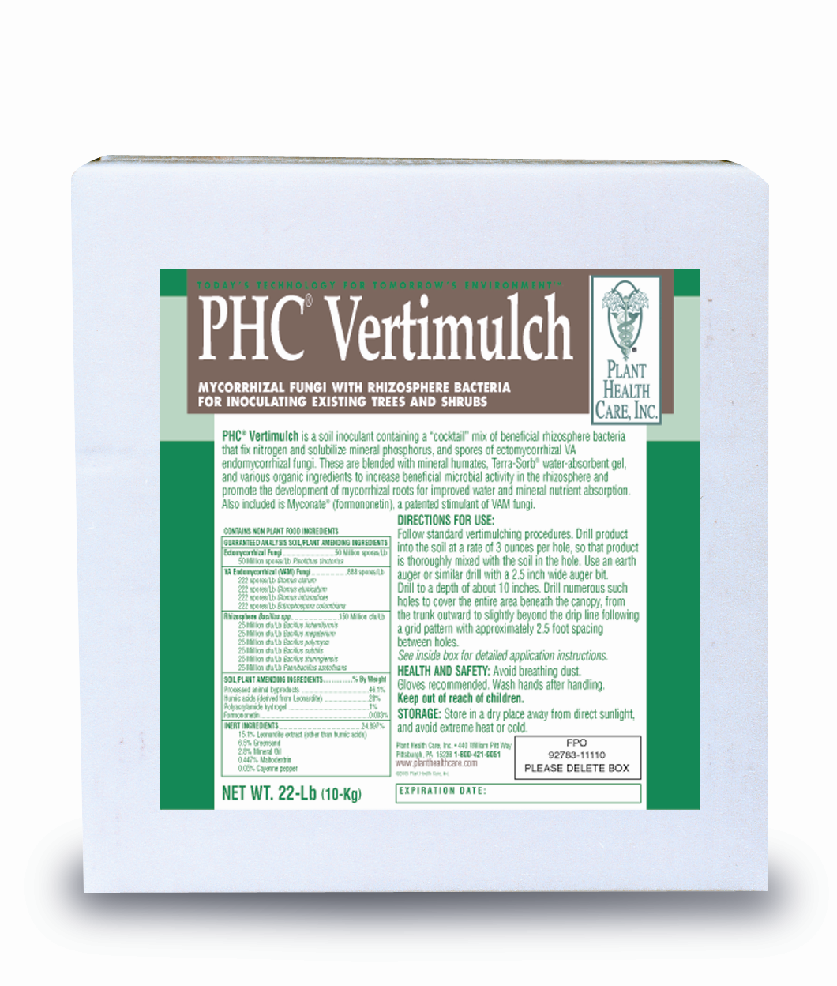

For Treatment of Mature Trees in Decline or Suffering Stress
PHC® Vertimulch: PHC® Vertimulch is a granular soil inoculant applied as a standard vertimulch, or by radial trenching techniques. It contains a cocktail mix of beneficial rhizosphere bacteria that fix nitrogen and solubilize mineral phosphorus, and spores of ectomycorrhizal and VA mycorrhizal fungi. These are blended with humates, Terra-Sorb® water-absorbent gel, and various organic ingredients to increase beneficial microbial activity in the rhizosphere and promote the development of mycorrhizal roots for improved water and mineral nutrient absorption.

Directions:
Vertimulch Treatment: Follow standard vertimulching procedures. Drill product into the soil at a rate of 3 ounces per hole, so that product is thoroughly mixed with the soil in the hole. Use an earth auger or similar drill with a 2.5-inch wide auger bit. Drill to a depth of about 10 inches. Drill numerous such
holes to cover the entire area beneath the canopy, from the trunk outward to slightly beyond the drip line following a grid pattern with approximately 2.5 foot spacing between holes. Two hundred (200) holes at this spacing will cover about 1250 square feet, equivalent to the area beneath a 40-ft diameter canopy.

Alternate Method Using Premixed Vertimulch Fill: Mix 5-Lbs PHC® Vertimulch per cubic foot of soil. Drill holes as described above and fill with mix.

Radial Trench Treatment: Mix PHC® Vertimulch with mulch or fill at a rate of 3-oz (1-scoop) per square foot of trench. For example, for a 4-inch wide trench, 3-oz of Vertimulch would treat 1-linear yard of trench. For wider or narrower trenches, adjust rate accordingly based on square foot coverage of the trench.

Product Specification
Processed animal byproducts……………………………..….46%
Humic acids derived from Leonardite…………………..…...28%
Terra-Sorb® hydrogel (polyacrylamide)……………….……...1%
Formononetin………………………………………………0.003%
Inert Ingredients ………………………………………….….23%
VA mycorrhizal fungi spores…………………………888 spores*/Lb
222 spores/Lb Glomus clarum
220 spores/Lb Glomus etunicatum
222 spores/Lb Glomus intraradices
222 spores/Lb Entrophospora columbiana

Ectomycorrhizal fungi (Pisolithus tinctorius)……………….50 Million spores* /Lb
*Fungal counts represent only spores, and do not refer to root fragments or other nonspore propagules.
Rhizosphere Bacillus………………………………………..150 Million/Lb

25 Million cfu/Lb Bacillus licheniformis 25 Million cfu/Lb Bacillus subtilis
25 Million cfu/Lb Bacillus megaterium 25 Million cfu/Lb Bacillus thuringiensis
25 Million cfu/Lb Bacillus polymyxa 25 Million cfu/Lb Paenibacillus azotofixans

